1. **Write a Python program to print "Hello Python"?**

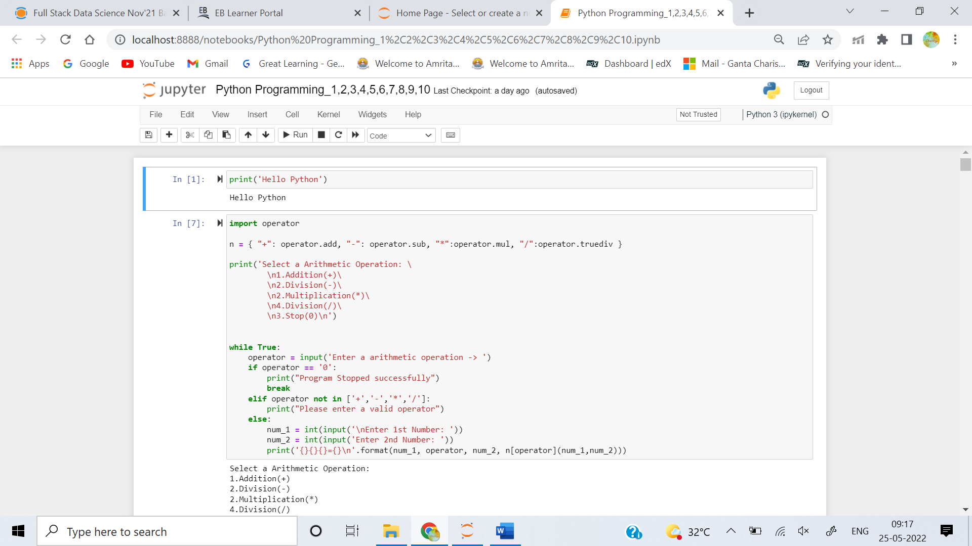

1. **Write a Python program to do arithmetical operations addition and division.?**

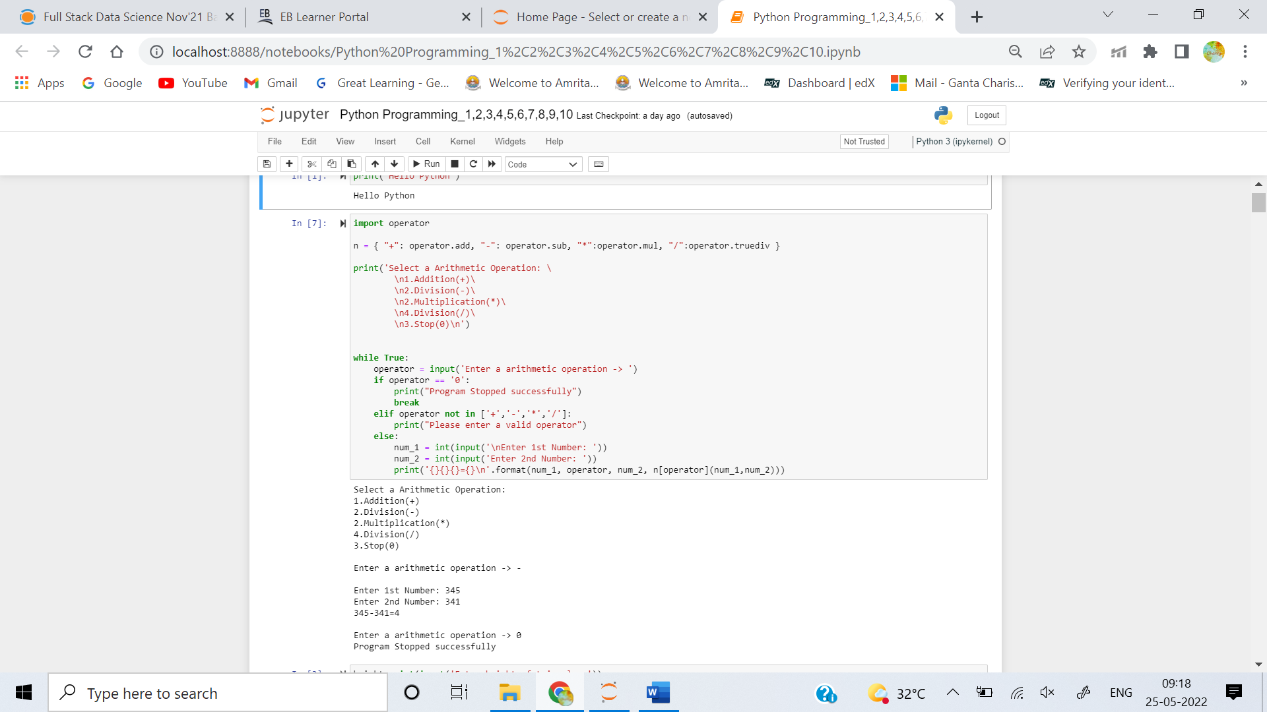

1. **Write a Python program to find the area of a triangle?**

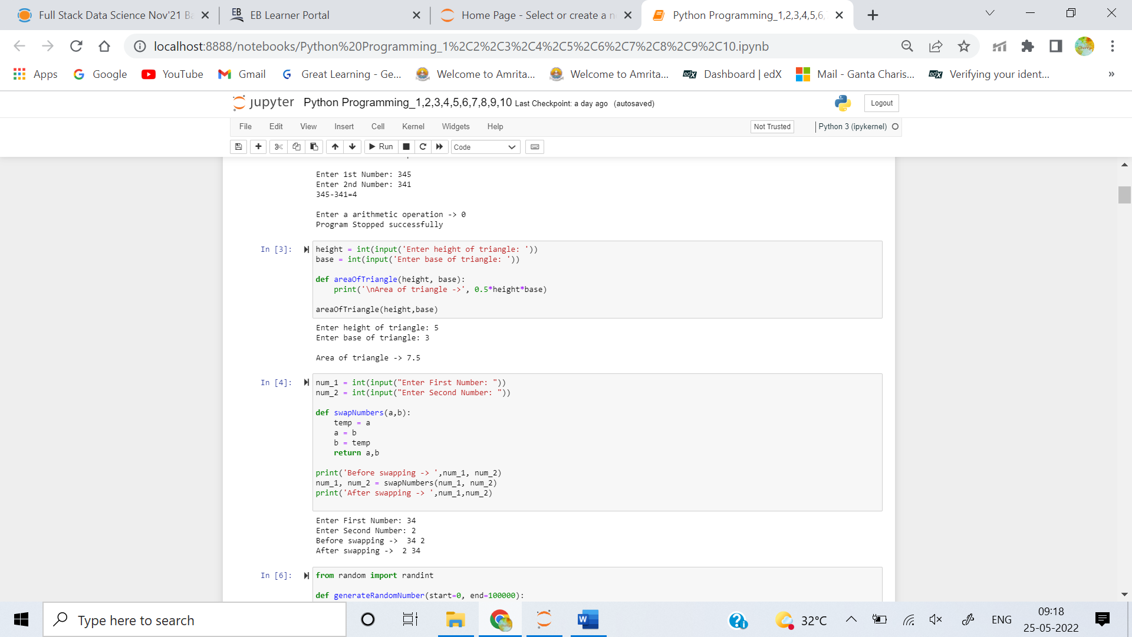

1. **Write a Python program to swap two variables?**



1. **Write a Python program to generate a random number?**

